The Parish of St. Nicholas Ribby cum Wrea

Minutes of the Annual Meeting of Parishioners held on Sunday 6th April 2025 in Church after the 9.30am Service

30 people were present.

Prayer

The Chairman, Rev Philip Chew, opened the meeting with a prayer.

Minutes of the 2024 Meeting

Minutes from the 2024 meeting had been distributed and placed in the church porch for review.

Copies were made available to those who requested them.

There were no comments or observations and thus, the minutes were accepted.

Election of Churchwardens

Rev Philip summarised the approach that had been adopted for the previous 12 months, with a team of 4 sharing the Churchwarden’s duties. The team, with their main focus, is:

Liz Almond (finance, administration; Treasurer)
Phil Heighway (School liaison and general duties)
Lynda Lancaster (fabric of the Church and general duties)
Tommy Taylor (Safeguarding Officer)

Rev Philip reported on how well this had worked, with the team sharing the duties very effectively, drawing on the particular skills of the individual Wardens.

Rev Philip confirmed that the team was happy to continue with their duties and asked for all four to be re-elected as Wardens for the next year. This was enthusiastically and unanimously agreed to.

Rob Taylor proposed a vote of thanks to the Wardens and a round of applause followed.

This concluded the Annual Meeting of Parishioners.

This was immediately followed by the Annual Parochial Church Meeting.

Minutes of the Annual Parochial Church Meeting held on Sunday 6th April 2025 in Church at 11am

Minutes of the 2024 Meeting

Minutes from the 2024 meeting had been distributed and placed in the church porch for review.

Copies were made available to those who requested them.

There were no comments or observations and thus, the minutes were accepted.

The Annual Parish Report and Accounts

The Annual Report and Accounts for 2024 had been distributed and placed in the church porch for review.

Copies were made available to those who requested them.

Liz Almond (LA), Treasurer, gave her financial report on the accounts and this is copied below:

The General Account for the year to December 2024 shows a surplus of £2,687 compared to a surplus of £5,165 in the previous year. Differences in individual expense items from 2023 to 2024 can be largely explained by the decision to increase our monthly Parish Share to an amount, although below the requested level, that is more than we paid in 2023. Utility costs fell by £1,000 by reducing gas consumption and lower priced contracts. The Major repairs to the Bells and the new AV system were supported by a total of £6,900 from grants and £5,248 from a legacy fund, respectively. The balance of expenditure was covered by VAT refunds from LPOW and general receipts.

Donations to church funds were received from St Nicholas Singers, Ladies Christian Fellowship (LCF), Happy Mondays and The Wednesday group.

The Centre accounts show a £922 fall in regular income. Long-term repairs and renewals which now stands at £10,386. As noted in my last AGM report, energy costs incurred by the Centre remain high leading to an annual loss again that was funded from reserves. The amount of Centre income is still insufficient to meet planned expenditure.

The Churchyard Fund has incurred expenditure of £2,888 over the year on general maintenance. With income of £790, as a result, the general account covered the expenses balance of £2,098.

The Sunday school account is self-explanatory but just to note a donation of £120 was given to Marie Curie in March.

Thanks to Chris Dickson for all his work in managing the cash received in Church and the Gift Aid Scheme. Especially for his monitoring of the Parish Giving Scheme that was introduced in October 2021. Without the work of Hayden Gigg our accounts would not be approved, so I thank him for all the time he gives and his hard work.

Lastly without the continued financial support of those within and outside our community, the cost of Ministry and upkeep of the fabric of St Nicholas Church could not be met. So, I thank you for your generous and continuing support.

Rev Philip commented that the rental charges for use of the Centre will be increased and that this should enable the income to balance the outgoings.

There were no further questions or comments and Rev Philip thanked LA for her work as Treasurer. There followed a hearty round of applause.

Election of Auditor

Hadyn Gigg, who was present at the meeting, is happy to continue as Independent Examiner for a further 12 months and he was duly re-elected.

Rev Philip thanked Hadyn warmly for all his work and led a round of applause.

Election of Representatives to the Deanery Synod

Rev Philip noted that we have three representatives to the Deanery Synod: Sandy Harris, Janet Reeh and Janet Wardell. All three are elected until 2026.

Election of Members to the Parochial Church Council (PCC)

Rev Philip outlined the proposed elections and re-elections:

Dr Cheryl Rees Griffiths and Mrs Janet Reeh are due for re-election to the PCC and both wish to stand for a further 3 year term.

There were no objections or observations for either of these individuals and both were duly re-elected to the PCC.

The current membership is:

Until 2026 Until 2027 Until 2028
Mr Liam Batty Mrs Liz Almond (Treasurer) Dr Cheryl Rees Griffiths
Mr Stanley Parkinson Mr Frank Andrews Mrs Janet Reeh
Mr Phil Heighway
Mrs Lynda Lancaster

Chairman’s Remarks

Rev Philip started by saying what a privilege it is to be vicar at St Nicholas and that he feels very supported, for which he is very grateful.

Rev Philip then commented that his report to the AGM was available to read within the Annual Report, copies of which were available, and his report is copied below:

In 2024 St Nicholas Church Ribby with Wrea continued to be a focal point for our parish, providing for the social and pastoral needs of our people and praising our Lord and Saviour with imaginative worship. I would particularly like to thank Liam our LLM for his contribution to preaching. JAM also presented fantastic worship on significant Sundays, especially Mothering Sunday and on JAM’s birthday. The house groups also took responsibility for some services during the year. On Palm Sunday we met on the Green for the Liturgy of Palms and then followed our processional cross to church to commemorate Jesus’ triumphant entrance into Jerusalem. Holy Week was marked with significant opportunities for prayer and preparation including Good Friday at the Cross on the small Green, for the final hour of our three-hour devotion across the benefice. We also held our Easter Vigil on Holy Saturday to dress our new Paschal Candle and celebrate the Resurrection of Lord Jesus Christ. Easter Sunday was a joyful occasion and attendance was good.

On June the 6th we participated in the village commemoration of 80 years since D Day. The PCC particularly pressed the point that this was a commemoration and not a celebration event. We hoped the celebration would be kept until 2025 for VE Day. We used the tent facilities remaining on the Green for the following Sunday the 9th when the service was led by our worship group. Later on the 29th of June we also held worship in the marquee erected to celebrate a significant Field Day anniversary.

This year we had 17 Confirmation Candidates as we welcomed Bishop Tony Porter (Retired Bishop of Sherwood) to our service on the 3rd of July. We had 3 weddings, 16 baptisms and 8 funerals at St Nicholas church throughout the year. School came into church every Thursday for their assembly in term time, and our mid-week communion services held on Thursday mornings continued to grow in attendance.

As we approached Christmas the church put more time between the Christmas concert and the Nine Lessons, like we did in 2023. The attendance at the Nine Lessons and Carols was excellent. The Nativity was performed by JAM in the morning of the same day, which was hugely enjoyable. This meant the church building was full twice in one day.

There were many social and fund-raising events across the benefice throughout 2024 Including our Hymnathon in September which was a United Benefice venture and included both of our Church schools, Ribby with Wrea, and St Michael’s Weeton. St Nicholas Singers and the worship group also contributed and they thoroughly enjoyed the day.

I would like to thank everyone for their support in 2024. Particularly our Church Officers: Our 4 Returning Wardens, Verger, Treasurer, PCC Secretary and our members, Sides Persons, Welcomers, Youth and children’s Workers, Webmaster, Social Committee, Community Rooms Committee, Magazine Contributors and Editor. In fact, I would like to thank all our worshipping community, for your hard work throughout another enjoyable year.

Any Other Business

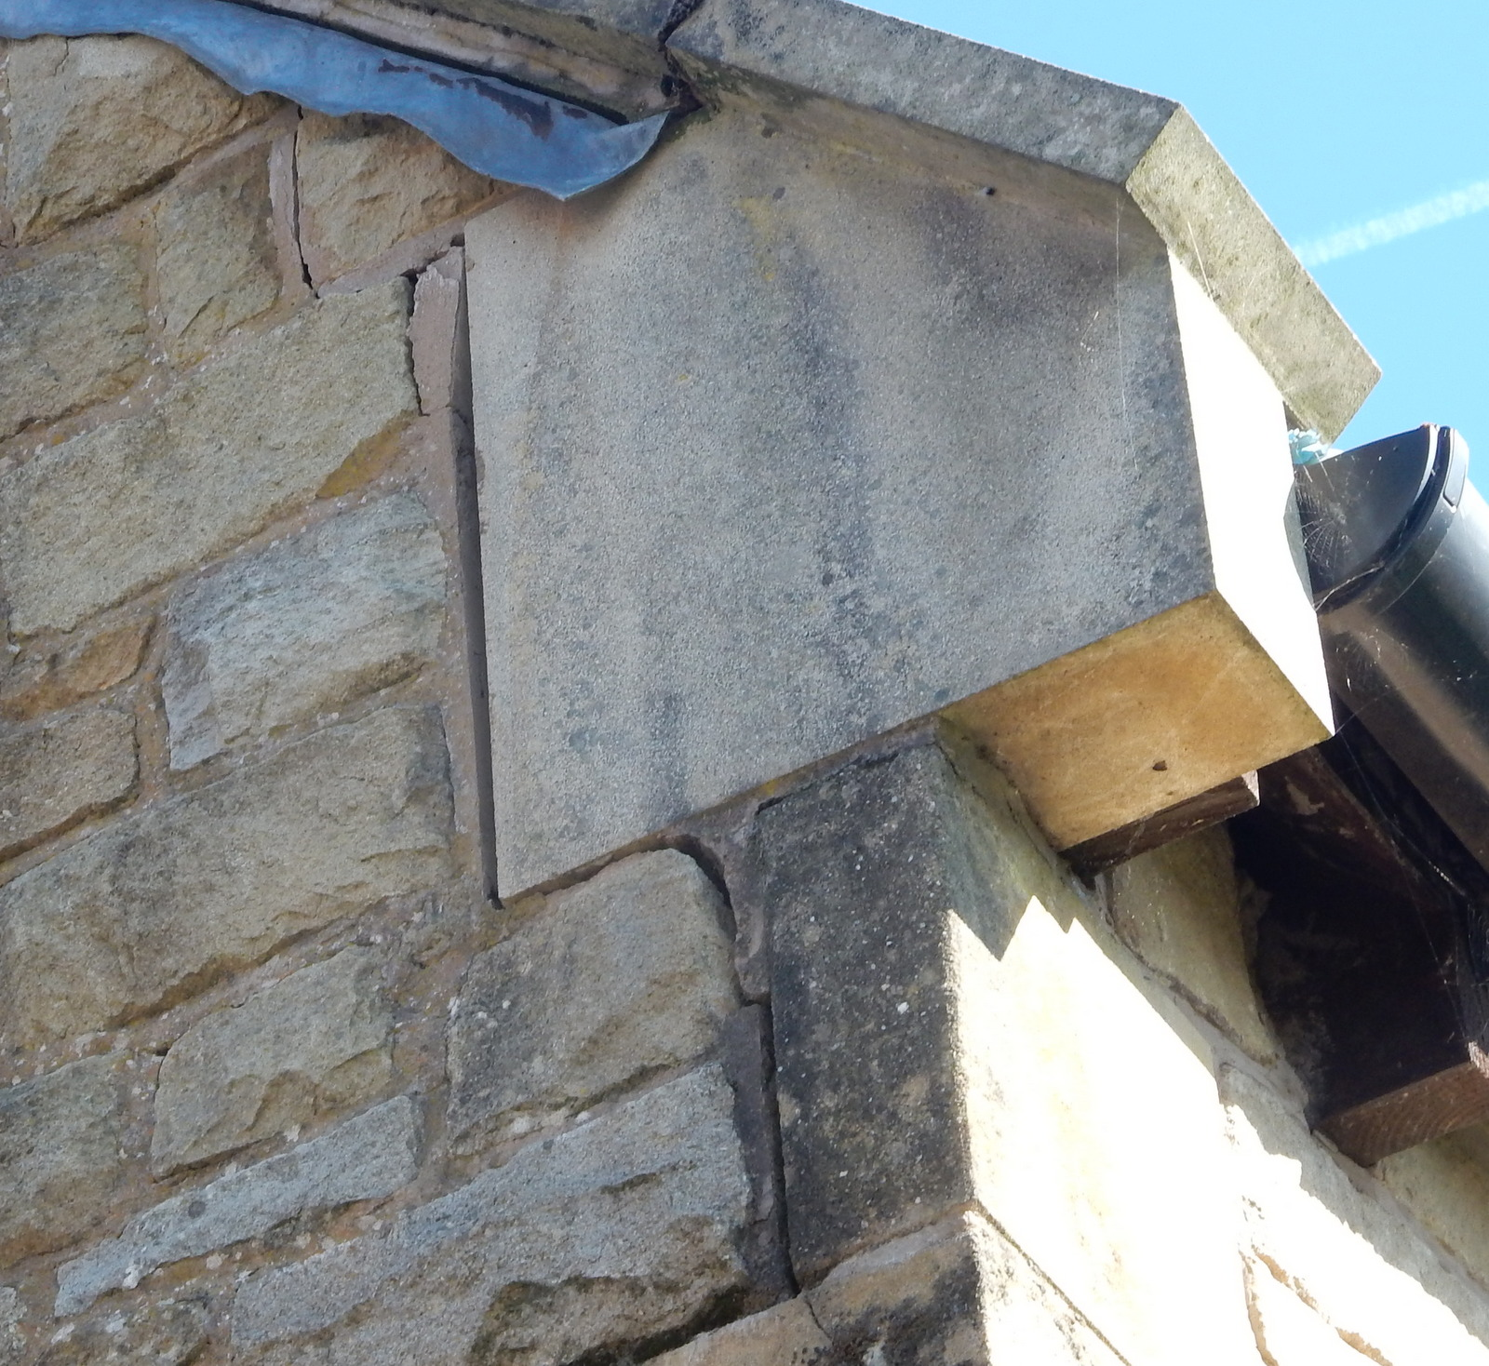
Paul Leeson asked whether there was a report on the condition of the stonework at the south-west end of the Community Centre extension where a gap has appeared between the stones (photo below).

Rev Philip thanked Paul for this observation and said that this matter would be investigated by the Wardens and the PCC.

The Secretary proposed thanks to Rev Philip for all his work, as well as to his wife, Janice for supporting him throughout. These sentiments were heartily agreed with, and a round of applause was given.

There being no further business, Rev Philip said Grace and the meeting was closed.

